#MyMission is...

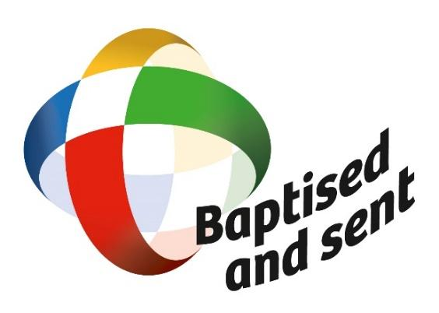
...and yours?
#MissionaryOctober

